Friday 13th June 2025
Challenge 2
Due in: Wednesday 18th June 2025
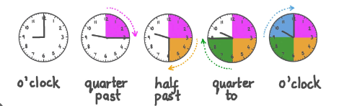
This week we have been learning about time in maths. We have been using clocks to work out o’clock, half past, quarter to and quarter past. We have been using the vocabulary: hour hand (shorter hand) and minute hand (longer hand) to help us.
Try to only use analogue clocks to help you tell the time, as we don’t need to use digital clocks in Year 2.
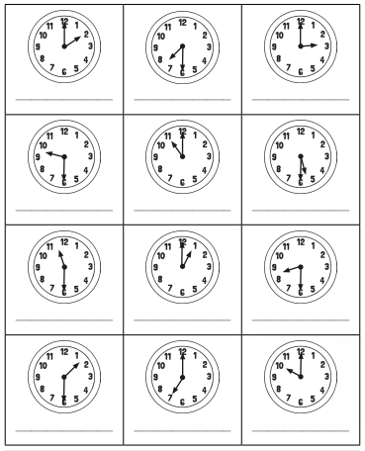
Have a go at either Challenge 1 (which includes all four) or Challenge 2 (This just focuses on o’clock and half past). You can always have a go at both as well!

