Homework- To compare and Order Numbers (Due in 23rd October)- Challenge 1
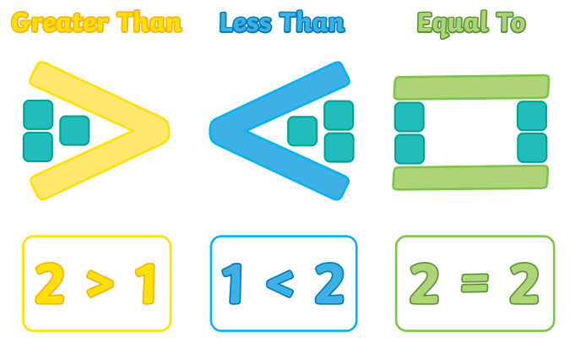

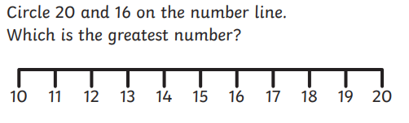
1).

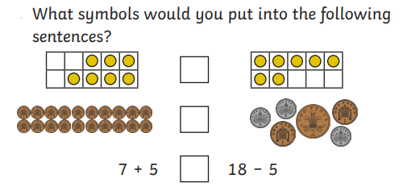
2).

3). Put the correct sign ( <, > or =) between these numbers. Remember the larger number or total sits at the open side of the symbol.



