Homework- To compare and order Numbers (Due in 23rd October)- Challenge 2
1). Compare these numbers. Write the number shown by the pictures then circle the correct sign. The first one is an example:
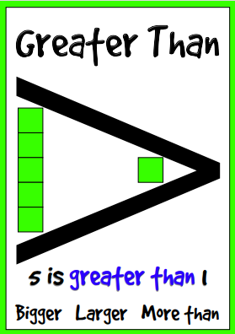
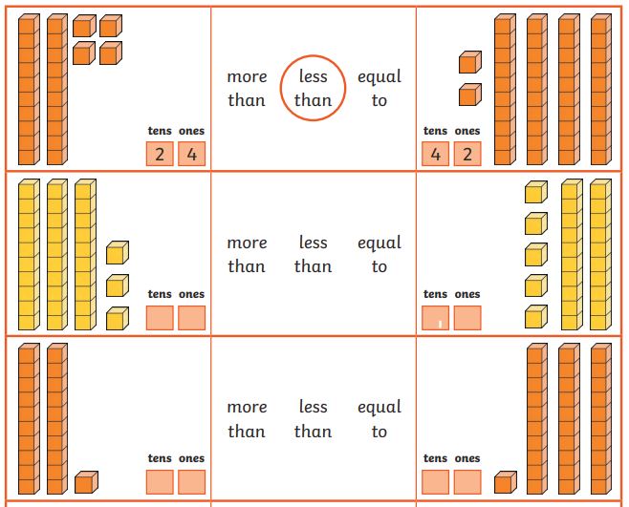

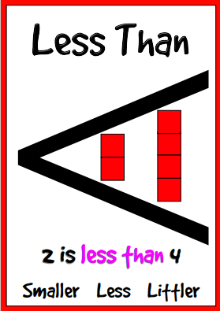

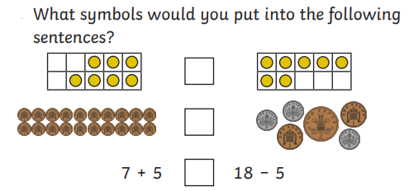
2).

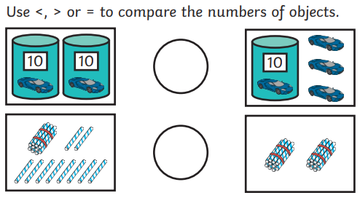
3).

