Lyppard Grange
DT Knowledge organiser
Year 6 | Mechanical systems – More Complex Electrical Systems
Design, make and evaluate a _________________ (product) for ______________(user) for _____________________(purpose) – (to be completed by year group)
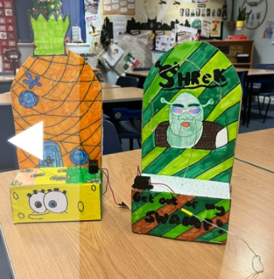
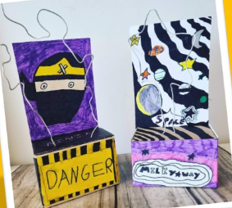
Examples of possible design and make tasks- alarms, security systems, electrical board games, greetings card with buzzer/ bulb or alarm system.
Year 6 objective-

Key knowledge-
- Understand and use electrical systems
- Apply an understanding of computing to program, monitor and control
- Create and modify a computer control program to enable an electrical product to work automatically in response to the environment

Key Skills-
- Use research to develop a design specification
- Communicate ideas through annotated sketches/ circuit diagrams
- Formulate a step-by-step plan, listing tools, equipment, materials and components
- Select and assemble materials connecting electrical components to make a reliable, functional product
- Continually evaluate and modify the working features of the product
- Test the system to demonstrate its effectiveness

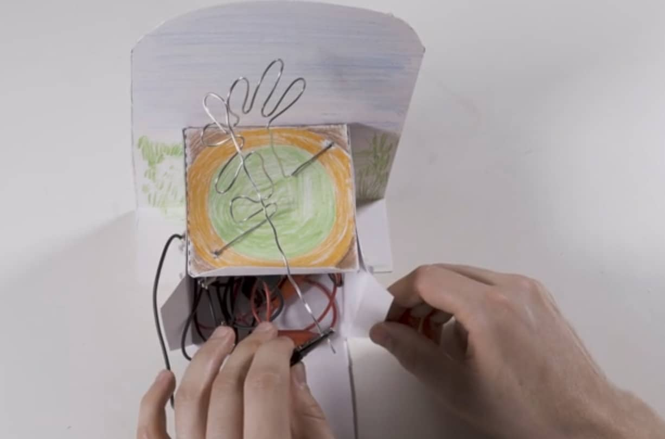
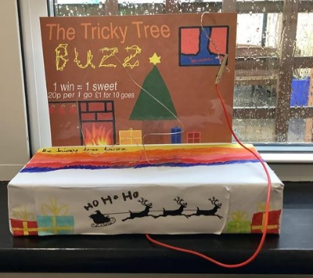
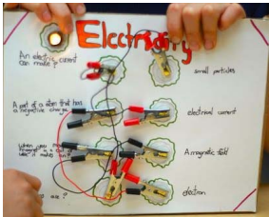

Link to Kapow- Elecctrical Systems- steady Hand Game
Vocabulary
Series circuit, parallel circuit, input devise, output devise, system, monitor, control, program
Output devises- components that produce an outcome e.g. bulbs and buzzers
Input devises- components that are used to control an electrical circuit e.g. switches or sensors

IEAs-
- Using research, discuss a range of relevant products that respond to changes in the environment using a computer control program such as automatic nightlights, alarm systems, security lighting e.g. Who have the products been designed for and for what purpose? How and why is a computer control program used to operate the products? What input devices, e.g. switches, and output devices, e.g. bulbs, have been used?
- Analyse existing children’s games
- Investigate electrical sensors such as light dependent resistors (LDRs) and a range of switches such as push-to-make switches, push-to-break switches, toggle switches, micro switches and reed switches. To gain an understanding of how they are operated by the user and how they work, ask the children to use each component to control a bulb in a simple circuit.

Design, Make and Evaluate Assignment (DMEA)
- Generate ideas through annotated sketches and cross-sectional diagrams.
- Produce annotated sketches to show the external shape ( 3D perspective drawing)
- Produce cross sectional diagrams to show internal and external components
- Label the type of circuit and switches used.
- Select from and use tools and equipment to cut, shape, join, and finish with some accuracy.
- Select from and use materials and components, including construction materials and electrical components according to their functional properties and aesthetic qualities (bulb/buzzer, wires, battery, container shape/size)
- Evaluate their ideas and products against their own design criteria and identify the strengths and areas for improvement in their work (include user and
- purpose across evaluation – what is effective to your audience? Would they buy this product? Why? If not, how could you improve it?

Focused Tasks (FTs)
- Explore electrical systems that could be used to control their products including simple, series, parallel circuits.
- Teach chn how to avoid making short circuits
- Explore nets to identify which will create shape for their base.
- Explore building nets using set squares/ rulers/ templates.

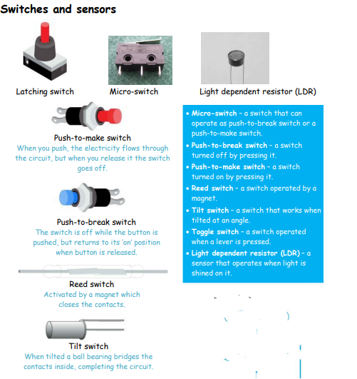
Health and safety-
Pupils should be taught to work safely, using tools, equipment, materials, components and techniques appropriate to the task.

See risk assessments saved in staff shared. Electrical Systems.

Top Tips
- Discuss the difference between products that rely upon timed events, such as traffic lights, and those that depend upon monitoring to make something happen such as a security alarm.
- Some children will be ready to use parallel circuits in their electrical systems and this enables two or more sensors or switches to be incorporated in their products.
- Have a ‘working’ circuit set up so that children can test suspect components.
- Some components e.g. buzzers and light emitting diodes (LEDs) need to be connected the right way round in a circuit, ensuring positive and negative match the poles of the battery.

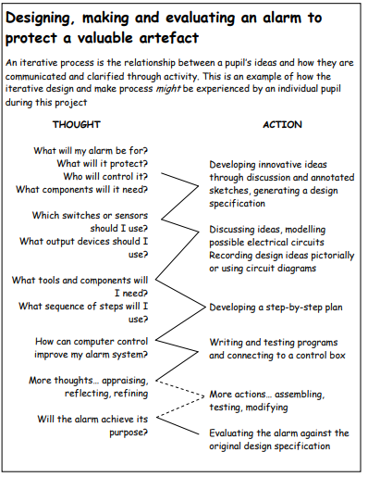

This follows on from-
Year 4-

