Half term coverage -Year 1 | Autumn 1 | Autumn 2 | Summer 1
Design and make task | Textiles -using templates and various joining techniques | Mechanisms- sliders and levers  Moving pictures | Food- Selecting and preparing raw ingredients-  Savoury snacks / fruit lollipops
Key knowledge | To know what equipment is needed to sew material together  To know what a design criteria is and how it can be used to create a product  To know how to evaluate my product and suggest improvements | To understand that different mechanisms produce different types of movement  To understand the steps to make a moving picture  To make a design based on criteria e.g. the mechanism should work smoothly/ it should make the right type of movement | To know that I have to wash my hands and keep work surfaces clean when preparing foods.  To know that everyone should eat at least 5 portions of fruit and vegetables a day  To know that fruit or vegetables can be farmed or grown at home  A vegetable is a plant used for food
Key skills | To design and create a product from textiles  To sew material together effectively at the seams  To thread and use a needle safely  To evaluate own and each other’s products against design criteria | To cut materials using scissors  To join paper and card using glue, paper fasteners and masking tape  Explore how moving objects work  Explore books that use simple sliders and levers  Generate ideas using design criteria, explaining what they could make  To plan by suggesting what to do next  To develop ideas using drawings and mock-ups using card and paper  To make a product that uses a lever or hinge to make a movement | To use knives to cut/slice food (with help)  Use equipment to peel, grate, juice foods safely  Design a product e.g. a sandwich, based on a simple design criteria  Taste and evaluate a range of fruit and vegetables  Select from a range of fruit and vegetables according to their characteristics e.g. colour, taste, texture  Evaluate my product against the design criteria
Vocabulary | Fabric, pattern, join, mark-out, template, running stitch, thread, needle  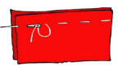  Running stitch- | Slider, lever, pivot, slot, card, masking tape, paper fastener, join,  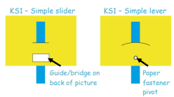  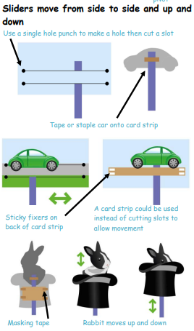 | Fruit, Vegetables, healthy, soft, juicy, crunchy, smooth, sharp, crisp, sour, seed, pip, slicing, cutting, squeezing, tasting

Half term coverage – Year 2
Design and make task | Structures- Freestanding structures e.g. bridges/ buildings/ chairs/ playground equipment | Mechanisms- wheels and axels- make a chassis- attach wheels and axis;  Balloon powered | Food- preparing fruit and vegetables (including cooking and nutrition requirements for KS1)
Key knowledge | To know how to join materials together effectively  To know that a range of tools can be used for different purposes e.g. cutting, sticking, bending, joining  To understand how structures can be made stiffer, stronger and more stable | A mechanism is a device used to create movement in a product  To know the difference between fixed and free moving axels  To know the purpose of the product (that the finished product can be moved on wheels with ease)  To know what components are needed to construct a moving vehicle and select materials which are most suitable | To know how to prepare food safely and hygienically  To know which equipment to use to prepare food (e.g. colander, sieve, peeler)  To know how to wash, peel, slice and grate fruit and vegetables  To know the food groups that healthy foods belong
Key skills | Explore initial ideas using drawings and mock-ups  To measure and mark out materials using safe ways of cutting  To investigate ways to strengthen materials by folding, joining or rolling  Evaluate their ideas and review their product against design criteria | To explore how moving objects work  To investigate wheels and axels and their strengths and weaknesses  Attach wheels to a chassis using an axel  Use a range of materials to create models with wheels and axels e.g. tubes, dowel, cotton reels  Generate ideas and design criteria  Develop ideas through drawings and mock-ups  To evaluate my product against design criteria | To use equipment to peel, slice and grate safely  To plan and prepare a nutritional meal/ snack  Design a product e.g. a smoothie, based on a simple design criteria  Taste and evaluate a range of fruit and vegetables  To evaluate their dishes and that of others and discuss how they could be improved
Vocabulary | Structure, cube, cuboid, cylinder, curved, straight | Vehicle, wheel, axel, axle holder, chassis, fixed, moving, mechanism  Ways to hold moving axels  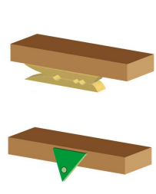  Clothes peg glued to underside of a box  Card triangles with holes for axels  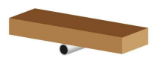  Use large paper or plastic straws fixed with masking tape. | Diet, fruit, vegetables, chopping board, grater, measuring jug, peeler, recipe, sieve, weigh

Half term coverage – Year 3 | Autumn 1 | Spring | Summer
Design and make task | Food-  Healthy and varied diet (including cooking and nutrition requirements for ks2) | Mechanical systems- levers and linkages | Structures-  Shell structures  (Including computer aided design)  Building a Roman town
Key knowledge | Know how to use a range of techniques to prepare ingredients e.g. peeling, chopping, grating, slicing, mixing, spreading, kneading and baking  The foods appearance is how it looks to the eye  That to be active and healthy food needs to provide energy for the body | Levers and linkages are devices that are used to create movement in a product  Distinguish between fixed and loose pivots  A paper faster that joins card strips together is a loose pivot  A paper faster that joins card to the backing card is a fixed pivot  In a lever and linkage mechanism the input movement is where the user pushes or pulls a card strip. The output movement is where one or more parts of the picture move. | To know how to construct strong, stiff shell structures  Develop and use knowledge of nets of cubes, cuboids and other 3d structures (where appropriate)  Know how to use and manipulate materials to create a structure
Key skills | Generate ideas through discussion to develop a design criteria for an appealing product for a particular user and purpose.  Use annotated sketches to develop ideas  Plan the stages of a recipe, listing ingredients, utensils and equipment  To select ingredients for my product  Carry out evaluations of ingredients and products, recording evaluations in tables and graphs  To work in a safe and hygienic way  To measure out my ingredients using scales  My food product is presented to impress the user  Evaluate the product against the design criteria | Investigate books with linkage and lever mechanisms  Generate ideas and design criteria through discussion  Use sketches and prototypes to develop ideas  Order the stages of making  Select appropriate tools to cut, shape and join paper and card  My product is finished well so that it is both useful and attractive  Make a product that uses lever and linkage mechanisms  Develop solutions to problems as they happen  Evaluate products against criteria, purpose and user | Use research to inform the design criteria for structures suitable to the context of the era  To investigate the construction of existing structures  Develop ideas using annotated sketches and prototypes  Use computer aided design to create nets for their products  Investigate ways of stiffening and strengthening structures e.g. corrugating, ribbing, folding, laminating  Use tools to measure, mark out, cut, score, shape and assemble nets made out of card  Evaluate their products against the design criteria and purpose
Vocabulary | Grams, kilograms, temperature, Celsius, hygiene, utensils, texture, appearance, | Levers, linkages, pivot, slot, bridge, guide, user, purpose, function, prototype, design criteria, design brief,  Linkage- the card strips joining one or more levers to produce the movement required  Slot- the hole through which a lever is placed to enable part of the picture to move  Guide/ bridge- short card strip used to keep the lever and mechanisms in place | Shell structure, three-dimensional, net, cube, cuboid, prism, vertex, edge, face, length, width, marking out, scoring, tabs, joining, assemble, stiff, strong, corrugating, laminating  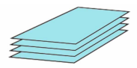  Laminating- glue together several layers of card  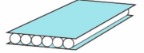  Ribbing- glue layers of straws between two layers of card  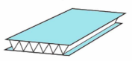  Corrugating- zig zag a piece of paper or card and glue between 2 layers of card

Half term coverage – Year 4 | Autumn 2 | Spring | Summer
Design and make task | Textiles- 2D shape to 3D product. | Electrical systems-  Simple circuits and switches (including programming and control) | Food- savoury biscuit/ snack  Healthy and varied diet (including cooking and nutrition requirements for ks2)
Key knowledge | To know different types of stitches and understand their functionality and aesthetics  To know how to evaluate their product against the product criteria, as a way to improve their work | To construct an electrical circuit using bulbs, switches and buzzers  A System is a set of related parts or components used to create an outcome.  To know how to make switches using various classroom materials e.g. card, foil, paper clips, paper fasteners  Know how to find a fault in a simple circuit and correct it | Know how to use equipment and utensils safely to prepare and combine food  e.g. peeling, chopping, grating, slicing, mixing, spreading, kneading and baking  To know that food is grown, reared and caught.  To know that a healthy diet is made up from a balance of food groups (eat well plate)  That to be active and healthy food needs to provide energy for the body
Key skills | To design a functional bag/ wallet with a fastening through annotated sketches  To select fabrics and fastenings according to their functional e.g. strength and aesthetic qualities e.g. pattern or colour  Research and investigate the features of bags/ wallets to inform design criteria  Investigate the effect of different stiches (how effective they are and their durability)  Plan the stages of making  Use a range of tools to stitch, cut and sew  Understand the need for seams and seam allowances  Evaluate and test final products against the design criteria | Investigate, analyse and evaluate familiar objects that use batteries to make them work.  Develop a design criteria to inform the design of a product that is fit for purpose  Generate ideas through discussion, annotated sketches/ exploded diagrams.  Order the stages of making.  Select from and use tools and equipment to cut, shape, join and finish with some accuracy.  Select the most appropriate techniques to make my product  Evaluate products against design criteria, identifying strengths and areas for improvement  To come up with solutions to problems as they happen  To make a product that uses electrical components such as switches, bulbs or buzzers.  The product has a good finish so that the user will find it both useful and attractive | Develop design criteria through discussion including appearance, taste, texture and aroma  Use annotated sketches to develop ideas  Plan the stages of a recipe listing utensils, ingredients and equipment  Select and use appropriate equipment/ utensils to combine ingredients including chopping boards, weighing scales, graters, measuring jugs, baking trays.  Select from a range of ingredients to make food products  Carry out evaluations of a range of products and ingredients. Record evaluations using tables or graphs.  Evaluate product against design criteria taking account of the views of others when identifying improvements
Vocabulary | 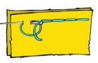  Templates, seam, seam allowance, fastening, annotated sketch, prototype, back stitch, running stitch, tacking, pattern pieces  Back stich-  Running stitch-  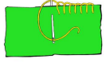  Blanket stitch- | Series circuit, fault, toggle switch, push to make switch, ush to break switch, battery, wire, insulator, conductor, crocodile clip,  System, input, output  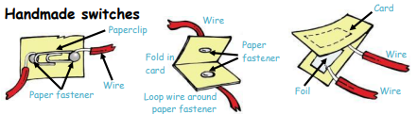  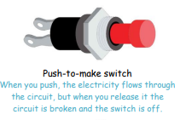  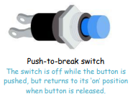  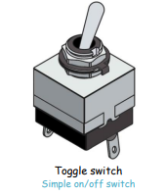 | Texture, taste, appearance, smell, savoury, hygienic, edible,  processed, seasonal, healthy/ varied diet

Half term coverage – Year 5 | Autumn 1 | Spring | Summer
Design and make task | Space buggies | Greek taverna / pop up restaurant | Survival structures  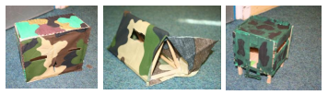
Key knowledge | Understand that mechanical systems have an input, process and output and how pulleys can be used to speed up, slow down or change the direction of movement  To know that a frame structure can be reinforced and strengthened with triangular shapes at the corners  Know how to measure and cut different materials including dowel accurately and safely | Particular dishes are associated with different cultures and places  Some ingredients are easier to grow in some parts of the world than others and are often found in dishes where they originate e.g. olives  Some ingredients are more available at certain times of the year than others  Know how to use utensils and equipment (including heat sources) to prepare and cook food e.g. knead, beat, rub and mix ingredients  Know how to use equipment/ utensils safely and hygienically | To know how to strengthen, stiffen and reinforce 3D frameworks
Key skills | Develop ideas through discussion, annotated drawings, exploded drawings and drawings from different views.  Formulate step by step plans including lists of tools, equipment and materials  Accurately measure lengths of wood, sawing and smoothing ends with sandpaper  Build a wooden pulley system  Create a chassis which will hold a motor  Attach a battery with wires to a motor  Evaluate the quality of the design throughout the process referring back to the design criteria | Generate ideas through research and discussion to develop a design brief and specification  Explore a range of initial ideas and make design decisions  Use annotated sketches to develop ideas  Write a step-by-step recipe including a list of key ingredients, equipment and utensils  Select and use appropriate equipment to measure and combine ingredients accurately  Make, decorate and Present the food product appropriately for the intended user  Carry out evaluations of products and ingredients, recording evaluations (e.g. tables/ graphs/ charts/ star diagrams)  Evaluate the product taking into account the views of others | Carry out research into users needs and existing products (surveys, interviews, questionnaires, web-based resources)  Develop a design specification taking account of time constraints, resources and cost  Generate ideas through discussion, prototypes and annotated sketches  Create a step-by-step plan including list of resources  Select and use tools competently to measures, mark out, cut, shape and join materials to make frameworks.  Use finishing/ decorative techniques suitable for the product  Investigate frame structures  Evaluate products against design criteria/ user and purpose and carrying out appropriate tests.
Vocabulary | Pulley, drive belt, axel, motor, circuit, switch, circuit diagram, exploded diagrams, mechanical system  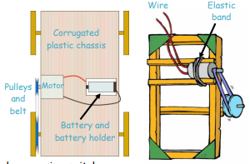 | Ingredients, spice, herbs, fat, sugar, carbohydrates, protein, vitamins, nutrition, varied, seasonality, | Frame structure, stiffen, stability, strengthen, reinforce, triangulation, stability, diagonal, horizontal, vertical

Half term coverage – Year 6 | Autumn 1 | Spring | Summer
Design and make task | Textiles- bags for life  Combining different fabric shapes | Food- celebrating culture and seasonality | Electrical systems – including programming, control and monitoring
Key knowledge | A 3d product can be made from a combination of pattern pieces, fabric shapes and different fabrics.  Fabrics can be strengthened, stiffened and reinforced where appropriate.  To know how to use a variety of stitches for functionality and aesthetics  To know how to use a sewing machine to join fabric (with adult supervision) | To know about the benefits of whole grain flour, opposed to a plain flour and the reasons why some types of bread, such as wholemeal, are healthier than others and can be a source of carbohydrate in a healthy balanced diet  To know the different tools and ingredients typically involved in breadmaking and the steps involved in the breadmaking process. Kneading is pulling and squeezing dough to make it smooth.  Dough is a mixture of flour, yeast and water before it is cooked. | Understand and use electrical systems  Apply an understanding of computing to program, monitor and control
Key skills | Develop an appealing and functional product with a fastening (zip, toggle, ties, press studs, buttons)  Generate ideas by carrying out research e.g. surveys, interviews, questionnaires  Develop ideas using drawings, mock-ups, templates, prototypes and computer aided design.  Incorporate CAM (computer aided manufacture) if appropriate e.g. printing on fabric using iron transfer paper  Produce detailed lists of equipment and fabrics  Formulate step by step plans  Select from and use a range of tools and equipment to make products that are accurately assembled and well finished.  Investigate and analyse textile products linked to their final product  Compare the final product to the design specification  Test final products, critically evaluating the quality, manufacture, functionality and fitness for purpose | Evaluate a range of bread through taste to inform own design criteria, considering appearance, flavour, texture and ingredients.  Record evaluations using e.g. tables/graphs/ charts/ star diagrams  Make design decisions to develop final product  Write a step-by-step recipe including ingredients, equipment and utensils  Make, decorate and present the food product for the intended purpose and user  Evaluate the final product taking into account the views of others when identifying improvements | Use research to develop a design specification  Communicate ideas through annotated sketches/ circuit diagrams  Formulate a step-by-step plan, listing tools, equipment, materials and components  Select and assemble materials connecting electrical components to make a reliable, functional product  Create and modify a computer control program to enable an electrical product to work automatically in response to the environment  Continually evaluate and modify the working features of the product  Test the system to demonstrate its effectiveness
Vocabulary | Seam, seam allowance, wadding, reinforce, hem, template, tacking, working drawing, pattern pieces, pins, needles, thread, mockup, prototype, applique, embroidery  Computer--aided design (CAD)  Computer-aided manufacture (CAM)  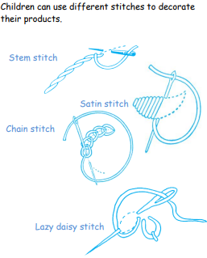  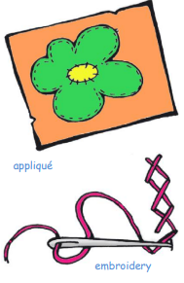 | Yeast, dough, flour, wholemeal, baking soda, spice, herbs, carbohydrate, savoury, seasonality, knead, combine | Series circuit, parallel circuit, input devise, output devise, system, monitor, control, program

